NorthStar Mustangs
Membership Application

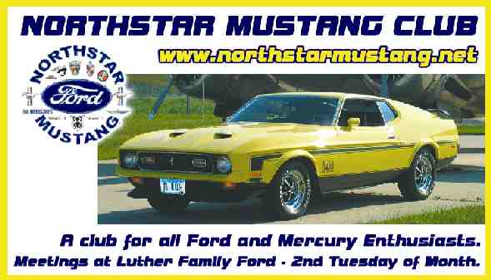

Club Dues are $15.00 per year and include:
*Subscription to our club's monthly newsletter
*Free classified advertising in newsletter
*Admission to all club events
*A whole lot of fun!

Name ____________________________________ Spouse __________________________________
Address________________________________ City__________________ State ______ Zip _______
Vehicle(s) and description: ____________________________________________________________
__________________________________________________________________________________
Phone ____________________ E-mail Address ___________________________________________
Comments_________________________________________________________________________
__________________________________________________________________________________

Print and send this application, payment for club dues to:
Northstar Mustangs
Attn: Elton Solseng
3037 166th Avenue S.E.
Harwood, N.D. 58042

